System Security: Lab Manual

MS Cyber Security

ITU Lahore



Submitted to: Muhammad Shehryar Raza

Submitted By: Eisha Nawaz

Roll No: MSCS22007

Lab 5: Web Authentication, Session Hijacking & CSP Bypass
Duration: 2 Hours
Mode: (Client / Attacker)
Tools:
- Burp Suite Community
- Browser DevTools
- Vulnerable web app (DVWA / custom app)

1. Scenario Description
A web app uses:
- Cookies for session tracking
- Weak or missing CSP
- No CSRF protection

2. Roles
- Victim User: Logs in normally
- Attacker: Intercepts traffic
- Defender: Fixes CSP and cookie flags

3. Environment Setup (15 minutes)
- Launch Burp Suite
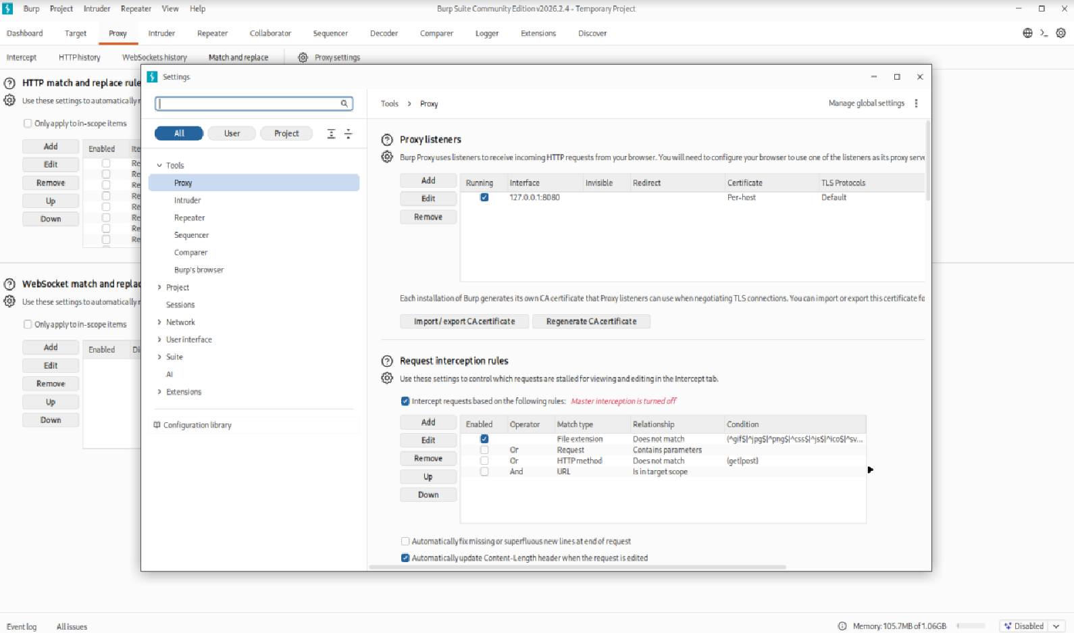

- Configure browser proxy
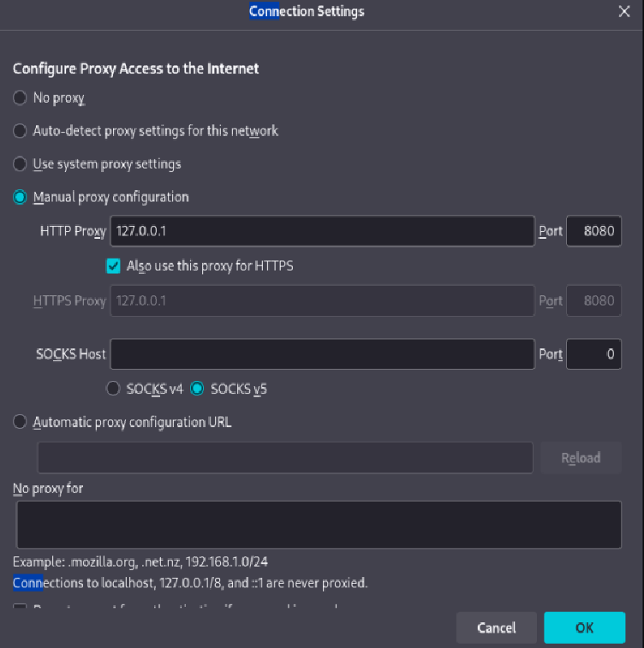

- Login as normal user

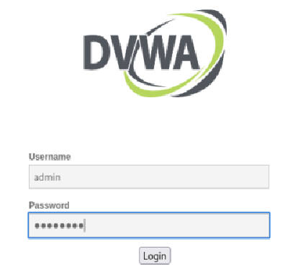
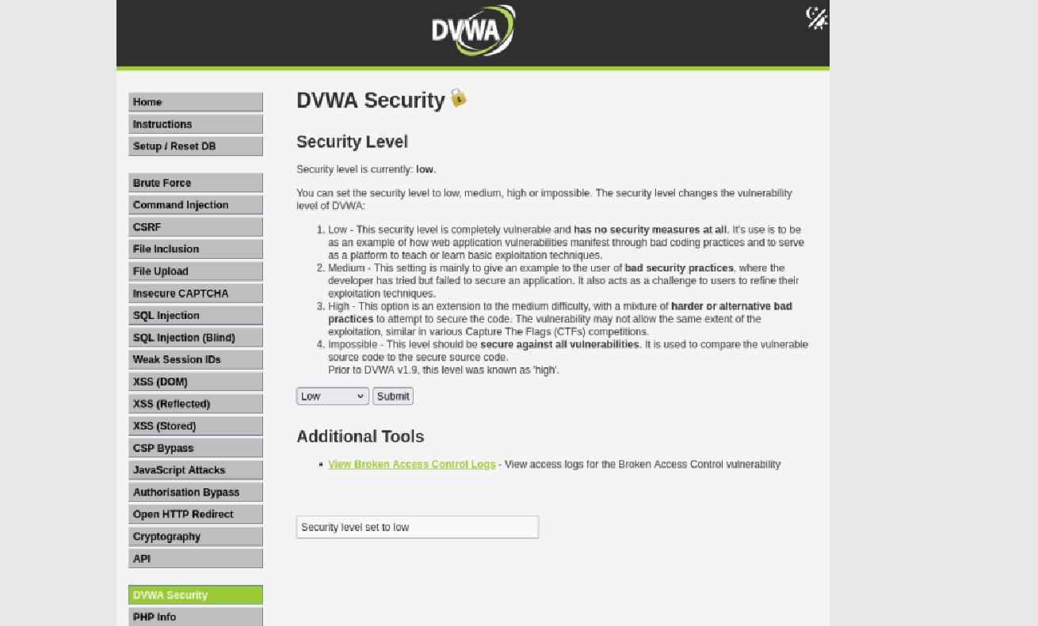

- Enable intercept

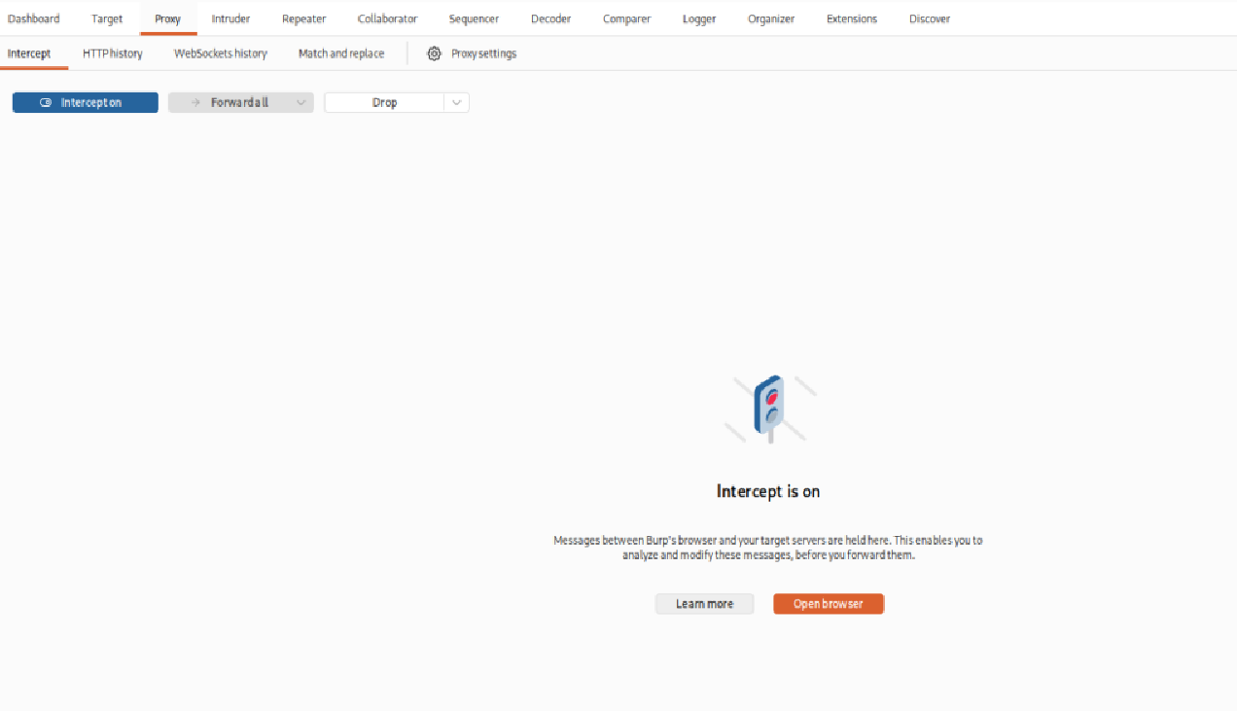

4. Step-by-Step Tasks

Task 1: Session Cookie Inspection (15 minutes)
In Burp:
- Inspect Set-Cookie header
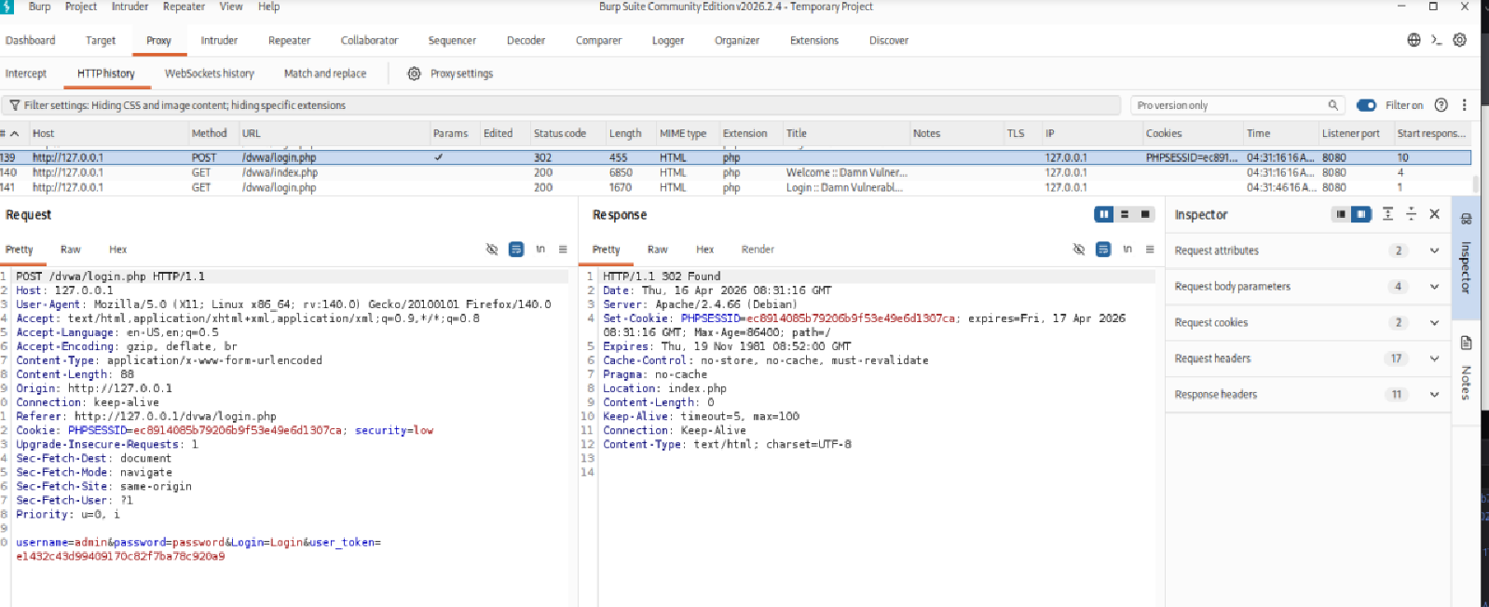
- Check for:
  - HttpOnly: it can be found in above SS; no javascript attack
  - Secure: Secure can be seen; cookie is sent over http
  - SameSite: it is equal to strict; protect against cross site Request Forgery(CSRF)
Checkpoint: Identify insecure cookie attributes.

Task 2: Session Hijacking (20 minutes)
- Copy victim’s session cookie
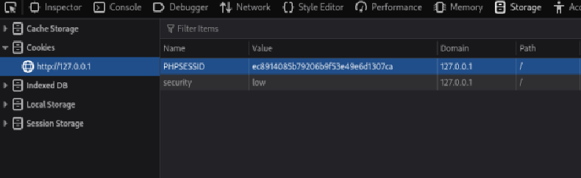
- Paste into attacker browser
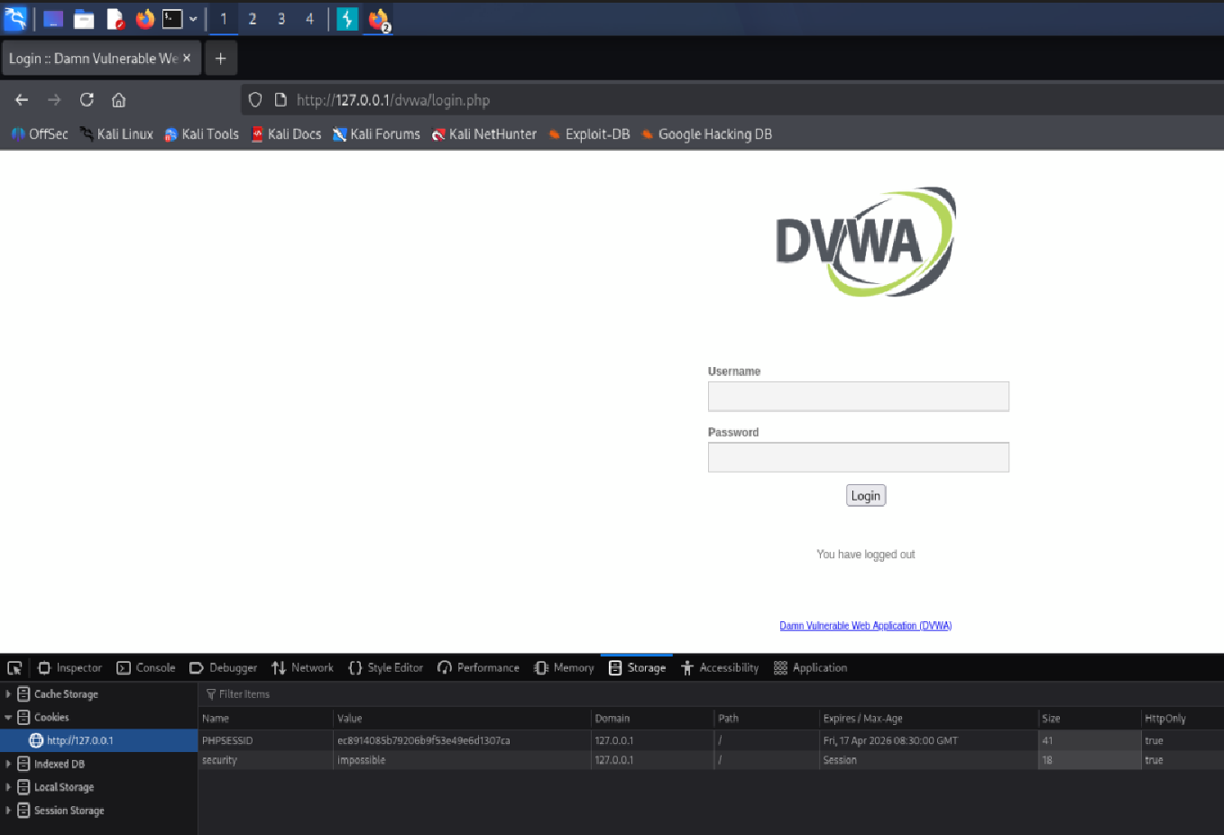
- Refresh page
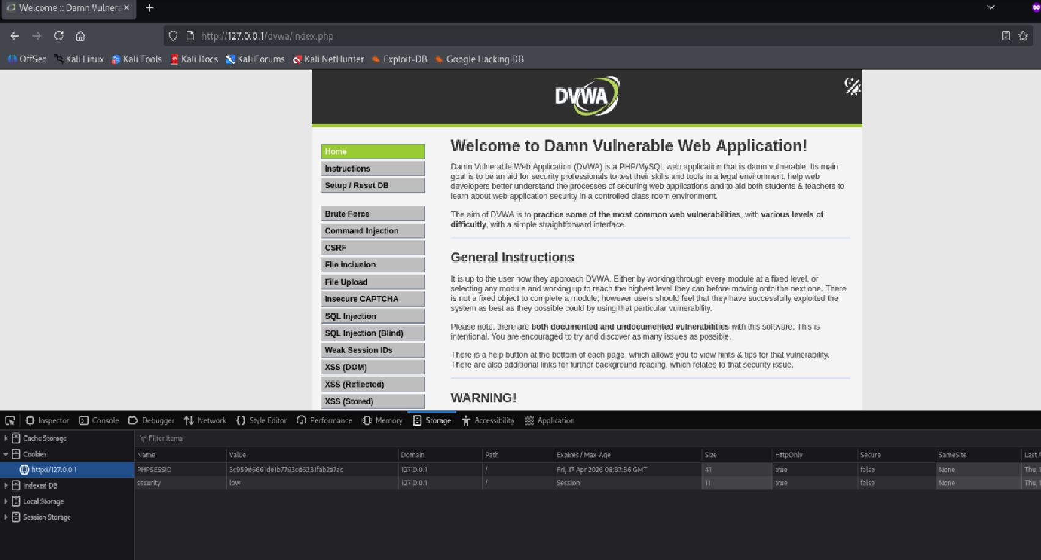
Observe:
- Successful session takeover

Task 3: CSP Analysis (15 minutes)
Inspect response headers:
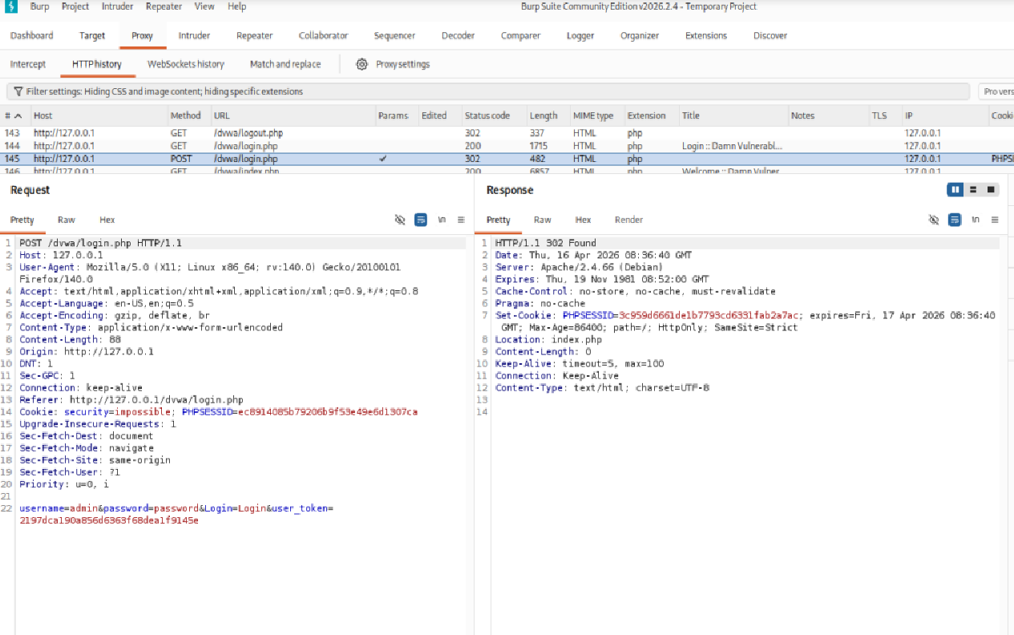
Content-Security-Policy: default-src 'self'
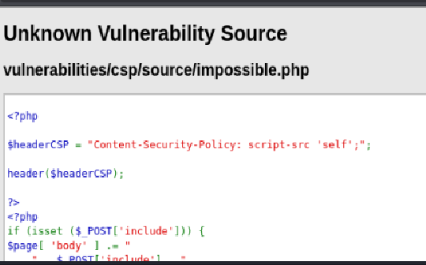
Identify weaknesses.
No Content-Security-Policy it removes a critical layer of defense-in-depth against Cross-Site Scripting (XSS) attacks. When the CSP header is absent, the browser defaults to allowing scripts, styles, and other resources to be loaded from any source, making the application highly susceptible to injection attacks

Task 4: CSP Bypass (25 minutes)
Inject payload via reflected input:
<script src="/evil.js"></script>
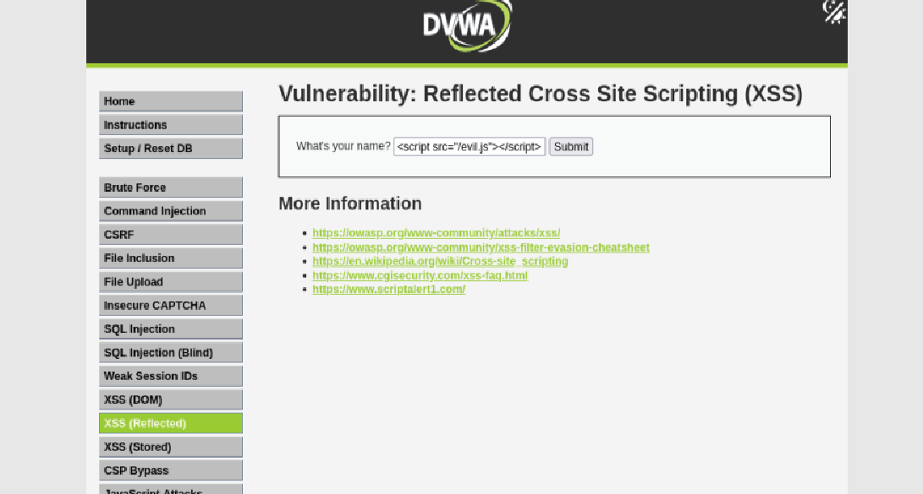
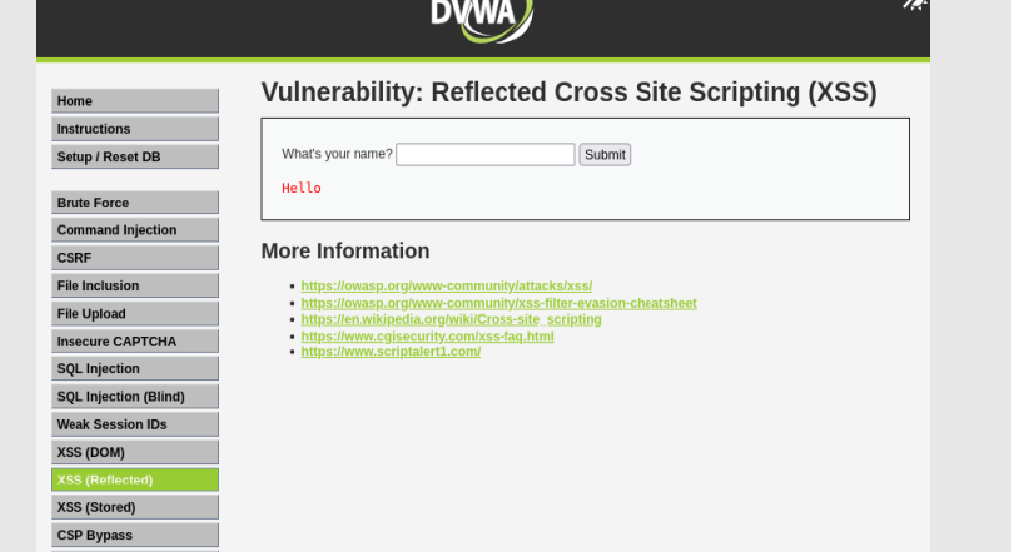
Or inline JS if allowed.
Observe:
- Script execution
- Cookie exfiltration simulation
Injected script executed successfully, indicating CSP is insufficient. Attack allows execution of malicious JavaScript.

Task 5: CSP Hardening (20 minutes)
Propose improved CSP:
Content-Security-Policy:
default-src 'none';
script-src 'self';
object-src 'none';
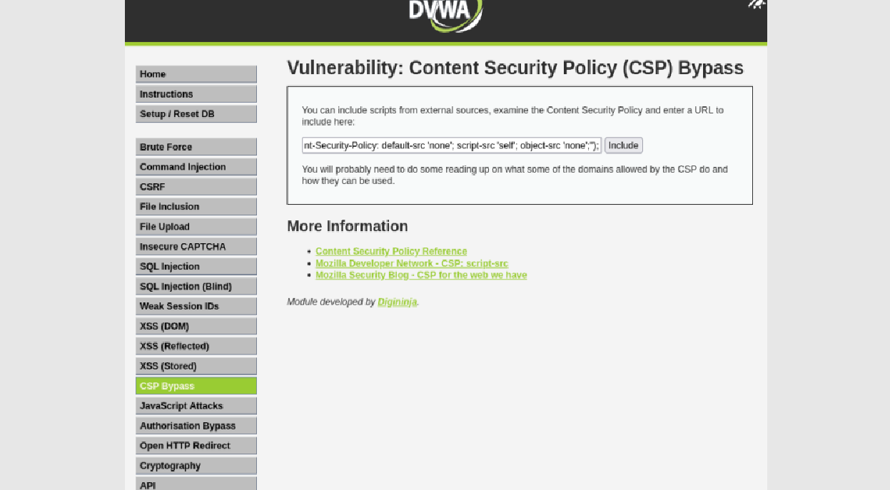
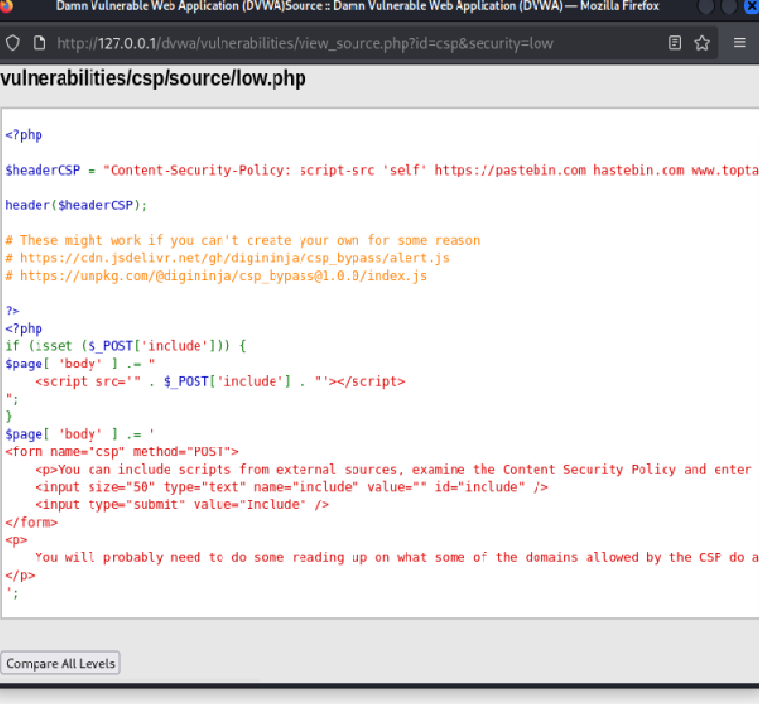
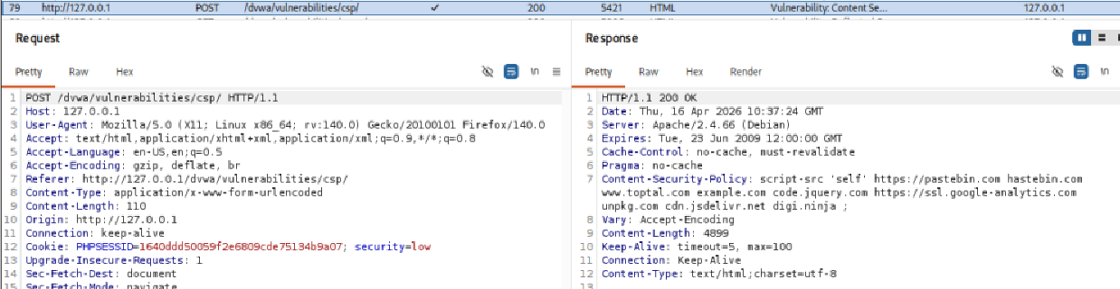
Test:
- Legit site works:
Normal DVWA pages continue to function correctly since all legitimate scripts are severed from the same domain, which is permitted by script-src ‘self’.
- Attack fails: The browser enforces the CSP before executing any script, so the injected <script> tag is rejected and the cookie is never exposed.

